Use Case Realisation Report (Analysis) - Manage Calendar
FOR
Volunteer Management System
(VMS)

CLIENT
PROJECT | Volunteer Management System (VMS)
TITLE | Use Case Realisation Report (Analysis) - Manage Calendar
VERSION | 0.3a0.2a
DATE | 14-Aug-2011
 | ORIGINATOR
 | Name / Signature | Team 8S
 | APPROVAL
 | Name / Signature | Phung Kim Cuong, Dio
Institute of Systems Science |  | Document Reference
25 Heng Mui Keng Terrence  Singapore 119615 |  | VMS/T-1.4.1/1

 | Acceptance
 | Customer Signature |  | Customer Signature
 | Name & Designation |  | Name & Designation
 | Date & Company Stamp |  | Date & Company Stamp

Revision History

Date | Version | Description | Author
12-Jun-2011 | 0.1a | Creation | Team 8S
12-Aug-2011 | 0.2a | Updates | Team 8S
14-Aug-2011 | 0.3a | Updates | Team 8S

Table of Contents

1. Brief Description 3
2. Flow of Events 3
2.1 Standard Flow 3
2.1.1 List Event 3
2.1.2 View Event 3
2.1.3 Create Event 4
2.1.4 Update Event 4
2.1.5 Publish Event 5
2.2 Exceptions 5
3. Interaction Diagrams 6
3.1 Collaboration Diagram for List Event 6
3.2 Collaboration Diagram for View Event 7
3.3 Collaboration Diagram for Create Event 8
3.4 Collaboration Diagram for Update Event 9
4. Participating Objects 9
4.1 User 9
4.2 Project Manager 9
4.3 Date 9
4.4 Event 9
4.5 Attendee 10
4.6 Project 10
4.7 CalendarListingScreen 10
4.8 CreateCalendarScreen 10
4.9 UpdateCalendarScreen 10
4.10 ViewCalendarScreen 10
4.11 HomeScreen 10
4.12 MainController 10
4.13 CalendarController 10
5. Class Diagrams 11
6. Derived Requirements 11
ANNEX D Amendment History 12

Use Case Realisation Report (Analysis) - Manage Calendar

Brief Description
The use case enables a User to view a calendar of events based on month.

Flow of Events
The standard flow of events for this use case and any exceptions are described in the following subsections. See section 3 for an overview of the participating Actors and Domain Objects.

Standard Flow
Precondition: User has logged in the system.
This use case provides the user interface related functionality that will be provided to the Project Manager for interaction with regards to calendar management, as follows:

List Event
- The use case starts when the User selects the calendar option from the HomeScreen. The HomeScreen.getCalendarMenu() operation is triggered.
- The getCalendarMenu() operation triggers the MainController.getCalendarMenu() which delegates to the CalendarController.getEventList() operation.
- Using the userID and date, the CalendarController.getEventList() operation triggers Event.getEventList() operation to retrieve the calendar event records using the userID and date. The CalendarController.getEventList() operation triggers also triggers the Attendee.getAttendee() operation to retrieve the attend records based on the eventID.
- The CalendarController triggers the CalendarListingScreen.show() operation to display the list of projects by triggering the Event.getAttribute() operation, Staff.getAttribute() operation and the Project.getProject() operation.
- The use case terminates.

View Event
- The use case starts when the User selects a record to view from the CalendarListingScreen. The CalendarListingScreen.getEvent() operation is triggered.
- Using the eventID, the CalendarController.getEvent() operation triggers Event.getEvent() operation to retrieve the calendar event details based on the eventID and the Attendee.getAttendee() operation is triggered to retrieve the attendees who are participating in the event.
- The CalendarController triggers the ViewCalendarScreen.show() operation to display the ViewCalendarScreen by triggering the Event.getAttribute() operation to retrieve the event details, the Attendee.getAttribute() operation to display the attendees’ details and Project.getName() to retrieve the project name.
- The use case terminates.

Create Event
- The use case starts when the User selects the create event option from the CalendarListingScreen. The CalendarListingScreen.getViewCreate() operation is triggered.
- The CalendarController triggers the CreateCalendarScreen.show() operation to display the CreateCalendarScreen.
- The User enters the calendar event details of the new calendar event into the text fields of CreateCalendarScreen.
- When the User selects the Create button in the form, the CreateCalendarScreen.validate() operation performs form validation based on the input fields.
- Upon successful validation, CreateCalendarScreen.createProject() operation triggers the CalendarController.createEvent() operation and provides the Event object by triggering the Event.getEvent(), retrieves the list of Attendee object by triggering the Attendee.getAttendee() operation and Project.getProject() operation to retrieve the project object to get the project ID to create a event. The createEvent() operation assigns a new event ID by using the operation Event.getNextEventID() operation.
- The CalendarController.createEvent() operation sets the date of created date of the event which the date is retrieved via the Date.getDate().
- The CalendarController triggers Event.createEvent() operation to create the new Event object details including name, description, location, startDate, endDate, attendees and remarks. The system displays an informational message for successfully updated message in the CalendarListingScreen by triggering the CalendarListingScreen.showMessage() operation.
- The use case terminates.

Update Event
- The use case starts when the Project Manager selects a record from the CalendarListingScreen. The CalendarListingScreen.getViewUpdate() operation is triggered.
- The CalendarController.getViewUpdate() operation triggers Attendee.getAttendee() operation to retrieve the attendee details and the Event.getEvent() operation is triggered to retrieve the event details.
- The CalendarController triggers the ViewCalendarScreen.show() operation to display the UpdateCalendarScreen by triggering the Attendee.getAttribute() operation to retrieve the attendee detail, the Event.getAttribute() operation and Project.getAttribute() to display the details.
- The User selects the Update button to update the updates the project details of the project into the text fields of UpdateCalendarScreen.
- When the User selects the Update button in the form, the UpdateCalendarScreen.validate() operation performs form validation based on the input fields.
- Upon successful validation, UpdateCalendarScreen.updateEvent() operation triggers the CalendarController.updateEvent() operation and provides the Event object to update the event.
- The CalendarController triggers Event.updateEvent() operation to update the new Event object details including including name, description, location, startDate, endDate, attendees and remarks. The system displays an informational message for successfully updated message in the CalendarListingScreen by triggering the CalendarListingScreen.showMessage() operation
- The use case terminates.

Publish Event
- The use case starts when the Project Manager selects the update project option from the CalendarListingScreen. The update option is performed by the Update Event use case.
- The Project Manager checks the checkbox Publish to publish the calendar to the team member’s calendar. The flow is the same as the Update Event use case with an additional indicator publishIndicator to be updated as Yes.
- The use case terminates.

Exceptions
The following exceptions were identified:
- Validation fails. If the CreateCalendarScreen.validate() operation fails, the project creation fails. An error message is displayed in the CreateCalendarScreen by triggering the operation CreateCalendarScreen.showMessage().
- Validation fails. If the UpdateCalendarScreen.validate() operation fails, the project creation fails. An error message is displayed in the UpdateCalendarScreen by triggering the operation UpdateCalendarScreen.showMessage().

Interaction Diagrams

Collaboration Diagram for List Event
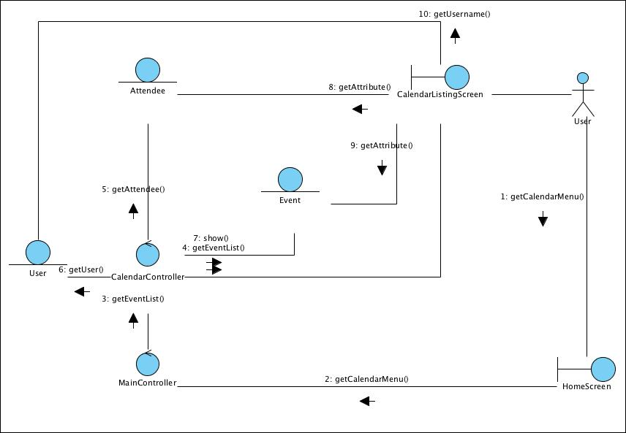
Figure 1 – Collaboration Diagram for List Event

Collaboration Diagram for View Event
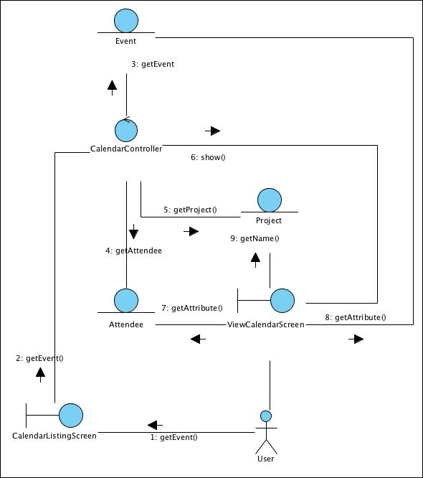
Figure 2 – Collaboration Diagram for View Event

Collaboration Diagram for Create Event
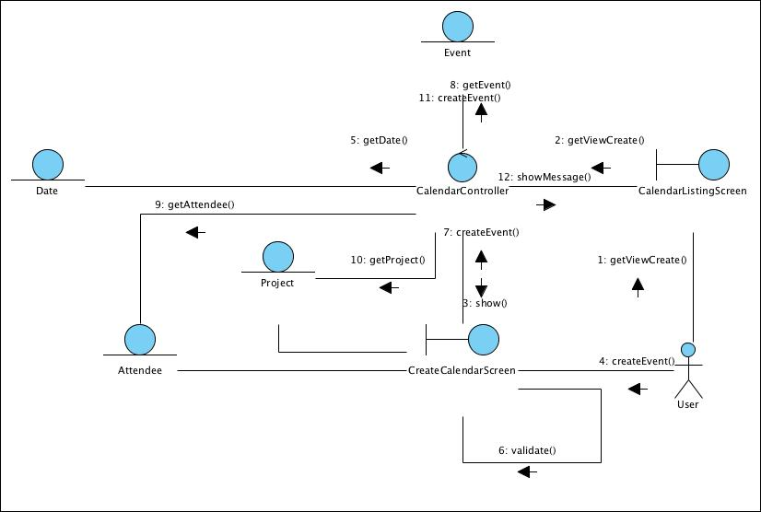
Figure 3 – Collaboration Diagram for Create Event

Collaboration Diagram for Update Event
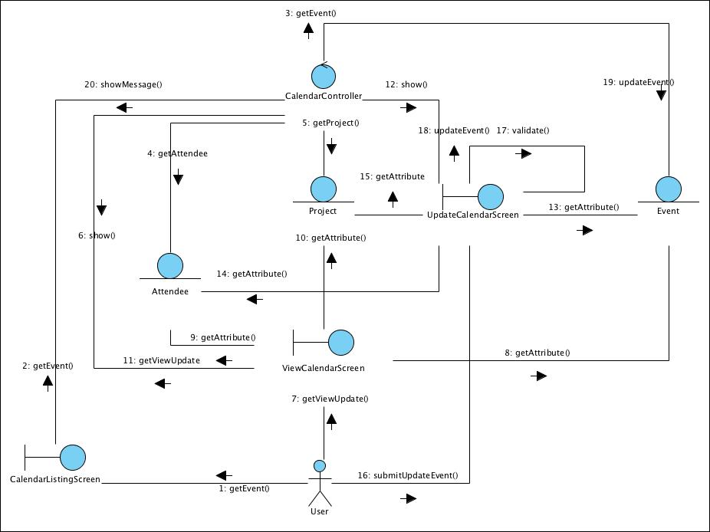
Figure 4 – Collaboration Diagram for Update Event

Participating Objects

User
This entity object stores the details concerning a user of the volunteer organisation. The primary attribute that it holds is the userID.

Project Manager
This is a Staff object type with a project manager role as an attribute.

Date
This entity object stores the current date.

Event
This entity object stores the details concerning a calendar event of a project’s calendar. The primary attribute that it holds is the projectID.

Attendee
This entity object stores the details concerning an attendee who will be participating in an event. The primary attribute that it holds is the userID.

Project
This entity object stores the details concerning a project of the volunteer organisation. The primary attribute that it holds is the projectID.

CalendarListingScreen
This boundary object is used for collection of event listing details. User actor uses this object.

CreateCalendarScreen
This boundary object is used for collection of event details, which a new event record is to be created. The User actor uses this object.

UpdateCalendarScreen
This boundary object is used for collection of event details, which an event record is to be updated. The User actor uses this object.

ViewCalendarScreen
This boundary object is used for collection of event details, which an event record is to be viewed. The User actor uses this object.

HomeScreen
This boundary object is used for redirecting and displaying of home screen details and menu. All the user actors use this object.

MainController
This control object co-ordinates the menu selection and dispatches of requests of the volunteer management system. It delegates the user requests to the specific use case control objects for carrying out the use cases.

CalendarController
This control object co-ordinates the creation, update and viewing calendar event record in the volunteer management system. It receives requests from the boundary objects allocated for the specific purposes, along with all the necessary details required for the execution of these requests.

Class Diagrams
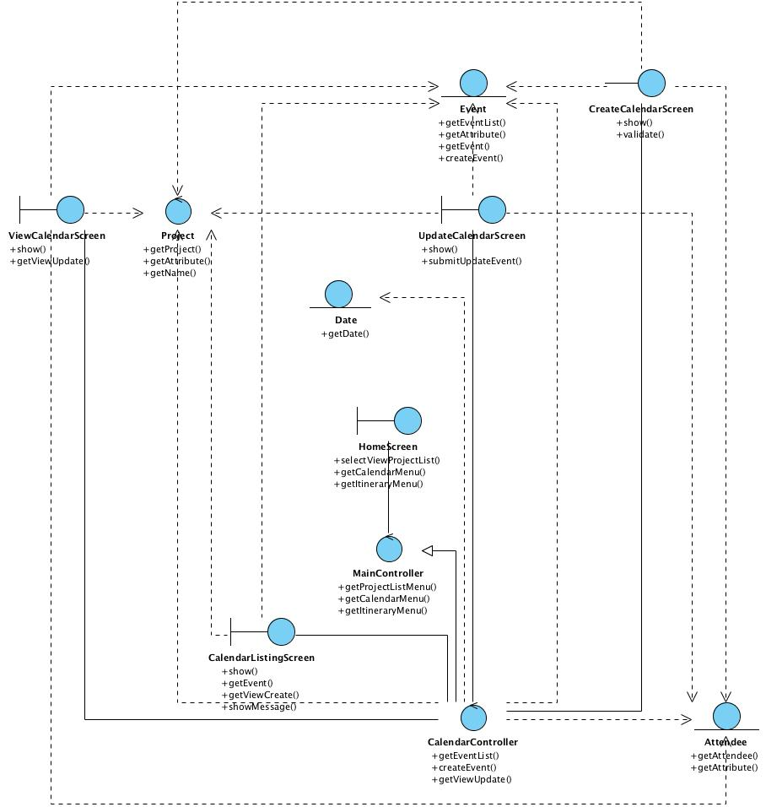
Figure 5 – Class Diagram

Derived Requirements
The Staff office PC (client system), keyboard and mouse will be used to process the project details and view all the system responses.

ANNEX D Amendment History

This is a record of all amendments made to the Document.
Version | Chapter / Section | Page No | Notes of Amendments or Changes

